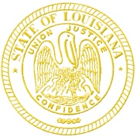 | State of Louisiana  Office of the Governor  DRUG POlicy
John Bel Edwards  Governor |  | Kristy Miller  Director
PUBLIC MEETING NOTICE

The Office of Drug Policy announces the following meeting to which all members of the public are invited to attend.

CANCELLED DUE TO LACK OF QUORUM

Subject: Drug Policy Board meeting

Meeting Date: Thursday, April 21, 2022

Meeting Time: 10:00 AM – 12:00 PM

Meeting Location:

Contact: Kristy Miller, 225-235-3073 or Kristy.Miller@la.gov

************************************************

AGENDA

Call to Order

Welcome and Introductions

Old Business
- Review and approve minutes from previous meeting

New Business
- Presentation: HOPE Council End-of-Year Report Overview

- Update: Progress of 2022 legislation

Other Business
- Office of Drug Policy updates
- Member agency updates

Public Comments

Upcoming Meetings

Adjournment

